Chemistry

Unit 3

Area of Study 1 Test:

Dynamic equilibrium systems

This sample test paper has been prepared as part of the Pearson suite of resources for the Year 12, Unit 3, ATAR Chemistry Course prescribed by the Western Australian School Curriculum and   
Standards Authority.

Time allowed

Reading time: 5 minutes Working time: 45 minutes

Materials required

An approved non-programmable calculator.

Chemistry Data Booklet. This may be downloaded from the SCSA website.

Structure of this paper

|  |  |  |  |  |  |
| --- | --- | --- | --- | --- | --- |
| Section | Number of questions available | Number of questions to be answered | Suggested working time (minutes) | Marks available | Percentage  of total test |
| Section 1:  Multiple choice | 8 | 8 | 13 | 16 | 23 |
| Section 2:  Short answer | 4 | 4 | 21 | 28 | 41 |
| Section 3: Extended answer | 2 | 2 | 11 | 25 | 36 |
| Total | | | 45 | 69 | 100 |

Section 1: Multiple choice 23% (16 marks)

This section has 8 questions. Answer all questions by circling the correct option. Marks will not be deducted for incorrect answers. No marks will be given if more than one answer is completed for any question.

Suggested working time: 13 minutes

_____________________________________________________________________________

1 Which one of the following is the equilibrium law expression for the reaction below?

Pb2+(aq) + 2Br–(aq) ⇌ PbBr2(s)

A 

B 

C [Pb2+(aq)][Br–(aq)]2

D 

2 Consider the following energy level diagram.

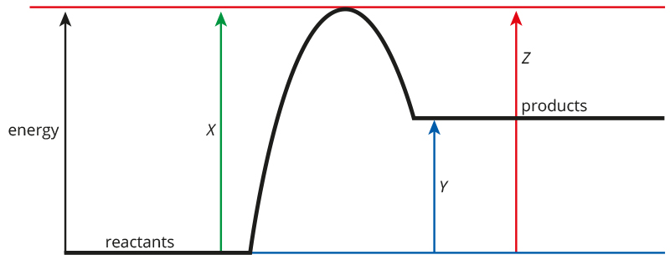

The effect of a catalyst on this reaction would be to change which one of the following values?

A X only

B Y only

C X and Z only

D X, Y and Z

3 One of the steps in the production of sulfuric acid involves the oxidation of sulfur dioxide to sulfur trioxide according to the following equation.

2SO2(g) + O2(g)  2SO3(g) ΔH < 0

Which one of the following changes will increase the amount of SO3(g) at equilibrium?

I increasing the temperature at constant volume

II decreasing the volume of the reaction vessel at constant temperature

III adding a catalyst at constant temperature

A I only

B II only

C I and III only

D II and III only

4 Nitrogen gas, N**2**(g), can react with oxygen gas, O**2**(g), to form nitrogen(II) oxide, NO(g). In a closed system, all three gases exist in equilibrium. The equation for this reaction is:

N2(g) + O2(g)  2NO(g) ΔH= +181 kJ

Which of the following changes, at constant temperature, will initiallyincrease the rate of the forward reaction but not that of the reverse reaction?

I increasing the partial pressure of O2(g)

II decreasing the partial pressure of NO(g)

III decreasing the volume of the reaction vessel

A I only

B II only

C II and III only

D I and II only

5 The value of the equilibrium constant for the equilibrium:

H2(g) + I2(g)  2HI(g)

is 160 at a temperature of 500 K and 54 at a temperature of 700 K. What can we deduce from this data?

A The forward reaction is exothermic.

B The reaction is faster at 500 K than at 700 K.

C The activation energy of the forward reaction is greater than the activation energy for the reverse reaction at both temperatures.

D The concentration of I2(g) in the equilibrium mixture will be higher at 500 K than at 700 K.

6 Ammonia can be produced from nitrogen and hydrogen as follows:

N2(g) + 3H2(g)  2NH3(g)

In the industrial production of ammonia, an iron oxide catalyst is used. What does this increase?

A the rate of the forward reaction only

B the rate of the forward and reverse reactions equally

C activation energy of the forward and reverse reactions equally

D activation energy of the forward reaction more than the rate of the reverse reaction.

7 In which one of the following equilibrium systems would the formation of products be favoured when the pressure is lowered at constant temperature?

A 2CO(g)  2C(s) + O2(g)

B PCl3(g) + Cl2(g)  PCl5(g)

C N2(g) + O2(g)  2NO(g)

D COBr2(g)  CO(g) + Br2(g)

8 The percentage yield of a particular equilibrium reaction has been studied at different temperatures and pressures. Some of the results are shown below.

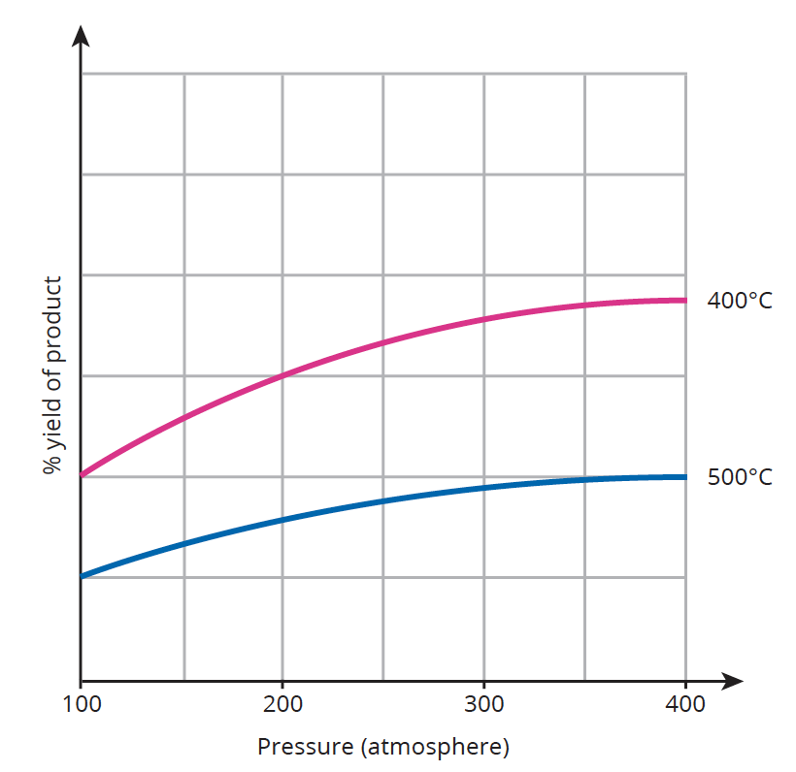

Which one of the following equilibrium systems would be expected to give the above results?

A 2NO2(g)  O2(g) + 2NO(g) ΔH > 0

B 3H2(g) + CO(g)  H2O(g) + CH4(g) ΔH > 0

C N2(g) + 3H2(g)  2NH3(g) ΔH < 0

D 4NH3(g) + 5O2(g)  4NO(g) + 6H2O(g) ΔH < 0

End of section 1

Section 2: Short answer 41% (28 marks)

This section has 4 questions. Answer all questions. Write your answers in the space provided.

When calculating numerical answers, show your working or reasoning clearly. Express numerical answers to three significant figures and include appropriate units where applicable.

Do not use abbreviations, such as ‘nr’ for ‘no reaction’, without first defining them.

Suggested working time: 21 minutes

_______________________________________________________________________________

Question 9 (9 marks)

Some carbon dioxide and hydrogen gas are placed in an empty container and heated to 2000 K. The following equilibrium is established:

CO2(g) + H2(g)  CO(g) + H2O(g)

a On the axes below, sketch a graph to show how the rate of the forward and reverse reactions change with time as the system approaches and reaches equilibrium at time x. Continue your graph to time y to indicate the rate of forward and reverse reactions at equilibrium.

Clearly label the forward and reverse reactions. (4 marks)

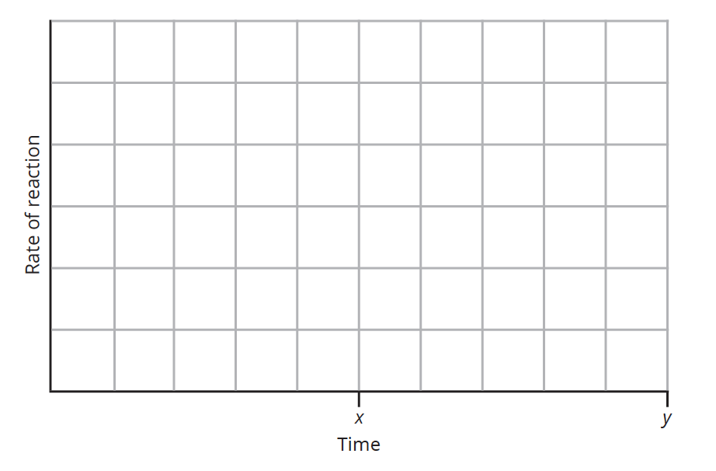

b The temperature of the equilibrium mixture is maintained at 2000 K but the volume of the vessel is doubled. Explain why there is no resultant change in the equilibrium amounts of reactants and products in terms of:

i the equilibrium law expression (3 marks)

______________________________________________________________________

______________________________________________________________________

______________________________________________________________________

______________________________________________________________________

ii reaction rates (2 marks)

______________________________________________________________________

______________________________________________________________________

______________________________________________________________________

______________________________________________________________________

Question 10 (5 marks)

a Bottled soda water contains dissolved carbon dioxide. In a closed bottle of soda water, the following equilibrium exists:

CO2(g)  CO2(aq)

Explain why the system is no longer at equilibrium once the bottle is open. Your answer should discuss reaction rates. (3 marks)

___________________________________________________________________________

___________________________________________________________________________

b Carbon dioxide gas also dissolves in the world’s oceans. The dissolved carbon dioxide reacts with water to establish the following equilibrium systems:

CO2(aq) + H2O(l)  H2CO3(aq)  H+(aq) + HCO3−(aq)

Explain, in terms of the equilibrium systems involved, why an increasing level of atmospheric carbon dioxide would increase the acidity of the ocean. (2 marks)

___________________________________________________________________________

___________________________________________________________________________

___________________________________________________________________________

Question 11 (8 marks)

In aqueous solution, the dichromate ion is orange and the chromate ion is yellow. These two ions are in equilibrium:

Cr2O72−(aq) + H2O(l)  2CrO42−(aq) + 2H+(aq)

a State two ways in which you could tell that equilibrium had been reached. (2 marks)

___________________________________________________________________________

___________________________________________________________________________

___________________________________________________________________________

b The following graph shows the rate of the forward and reverse reactions for this equilibrium. The temperature is kept constant throughout the experiment. At time t1 a change, other than a change in amount of CrO42−(aq), is imposed on the system.

The system responds to the change and a new equilibrium is reached at t2.

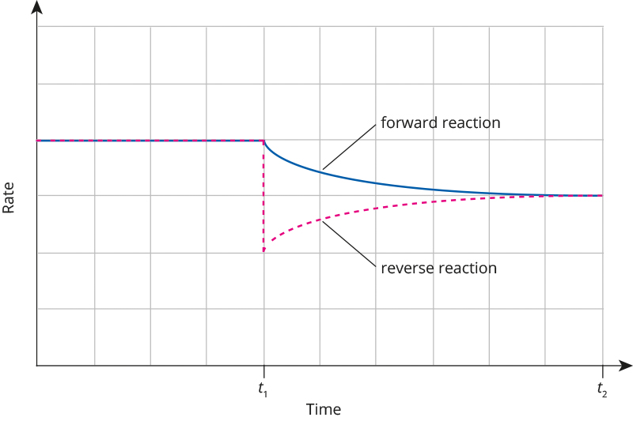

i What could have caused the change at time t1? (1 mark)

______________________________________________________________________

______________________________________________________________________

ii Describe how and explain why the colour of the equilibrium mixture at t2 will differ from that at t1. Your answer should discuss reaction rates. (3 marks)

______________________________________________________________________

______________________________________________________________________

______________________________________________________________________

iii Will the value of the equilibrium constant at the new equilibrium at t2 be greater than, the same as or smaller than that at t1? Justify your choice. (2 marks)

______________________________________________________________________

______________________________________________________________________

______________________________________________________________________

Question 12 (6 marks)

The following graph shows the kinetic energy of gas molecules in a reaction mixture at 300 K.

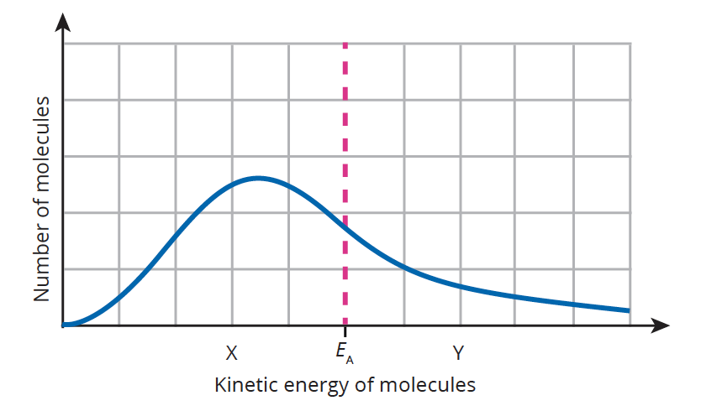

The point EA represents the activation energy required for an uncatalysed reaction to occur.

a i On the above graph, sketch the kinetic energy of the molecules if the temperature was increased. (1 mark)

ii Use your sketched graph to explain why an increase in temperature results in an increase in reaction rate. (2 marks)

______________________________________________________________________

______________________________________________________________________

______________________________________________________________________

b i For a catalysed reaction, would the activation energy be more likely to be at X or Y? State a reason for your answer. (2 marks)

______________________________________________________________________

______________________________________________________________________

ii Use the graph and your answer above to explain why a catalyst increases the rate of a reaction. (1 mark)

______________________________________________________________________

______________________________________________________________________

______________________________________________________________________

## End of section 2

Section 3: Extended answer 36% (25 marks)

This section has 2 questions. Answer both questions. Write your answers in the space provided.

When calculating numerical answers, show your working or reasoning clearly. Express numerical answers to three significant figures and include appropriate units where applicable.

Do not use abbreviations, such as ‘nr’ for ‘no reaction’, without first defining them.

Suggested working time: 11 minutes

________________________________________________________________________________

Question 13 (13 marks)

Nitrogen dioxide, NO2(g), is a dark brown gas. Two moles of NO2(g) combine to form the colourless gas dinitrogen tetroxide, N2O4(g). These two gases exist at equilibrium as shown in the following equation:

2NO2(g)  N2O4(g)

Some NO2(g) is placed in an empty gas syringe and allowed to come to equilibrium with N2O4(g). The following graph shows the change in concentration of NO2(g) in the syringe over 60 seconds. At the 60-second mark, the temperature of the system is increased at constant volume.

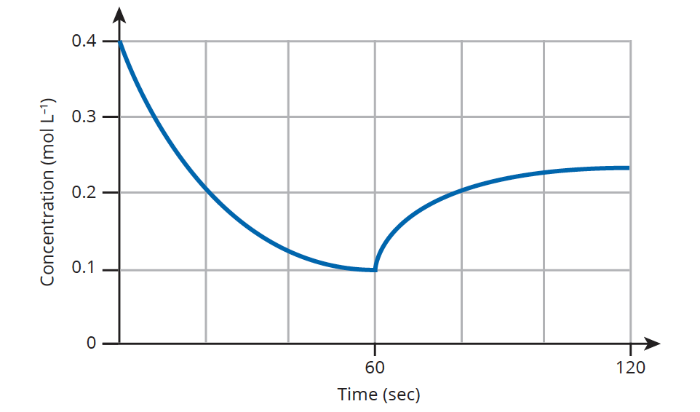

a Write the equilibrium law expression for this equilibrium system. (1 mark)

___________________________________________________________________________

___________________________________________________________________________

b Describe the colour change that would be observed in the syringe contents over the first 60 seconds. (1 mark)

___________________________________________________________________________

___________________________________________________________________________

c On the above graph, sketch the expected change in concentration of N2O4(g) for the first 60 seconds. (2 marks)

d Explain, in terms of rates of the forward and reverse reactions, why the concentration of NO2(g) in the syringe decreases rapidly at first then remains unchanged from the 55- to the 60-second mark. (4 marks)

___________________________________________________________________________

___________________________________________________________________________

___________________________________________________________________________

___________________________________________________________________________

___________________________________________________________________________

___________________________________________________________________________

___________________________________________________________________________

e From the information given, deduce whether the formation of N2O4(g) from NO2(g) is an endothermic or exothermic process and explain your reasoning. (2 marks)

___________________________________________________________________________

___________________________________________________________________________

___________________________________________________________________________

___________________________________________________________________________

f The syringe and contents are returned to room temperature and the plunger of the gas syringe pushed inwards so as to increase the internal pressure.

Provide an explanation for each of the following observations. (4 marks)

|  |  |
| --- | --- |
| Observation | Explanation |
| As soon as the plunger of the syringe is pushed inwards, the colour of the contents of the syringe becomes significantly darker brown. |  |
| After a few minutes, the colour of contents of the syringe have become paler, but not as pale as before the plunger was pushed inwards. |  |

Question 14 (12 marks)

In the lungs, the exchange of oxygen and carbon dioxide takes place when blood vessels pass around tiny air sacs called alveoli. Oxygen gas in the alveoli dissolves into the blood plasma (which is mostly water) then enters red blood cells while carbon dioxide leaves red blood cells to dissolve in the plasma and then enter the alveoli. The equilibria involved in the exchange between the plasma and alveoli are:

O2(g)  O2(aq)

CO2(aq)  CO2(g)

a State the conditions, in terms of the O2 and CO2 gas pressures, that will favour the uptake of oxygen by the blood and release of carbon dioxide from the blood. Explain your answer with reference to rates of reactions. (4 marks)

___________________________________________________________________________

___________________________________________________________________________

___________________________________________________________________________

___________________________________________________________________________

___________________________________________________________________________

Red blood cells contain haemoglobin, Hb, which carry oxygen as oxyhaemoglobin, HbO2, from the lungs to body cells and carry carbon dioxide as carbaminohaemoglobin, HbCO2–, from body cells to the lungs. This transport and exchange of gases involves three equilibria that take place in a red blood cell as follows

1 CO2(aq) + HbO2(aq)  HbCO2– + H+ + O2(aq)

2 CO2(aq) + H2O(l)  H2CO3(aq)  HCO3–(aq) + H+(aq)

3 HbO2(aq) + H+(aq)  H+Hb(aq) + O2(aq)

b For each of the species listed below, state whether its concentration in a red blood cell is at its highest when a red blood cell is just leaving the lungs or when it is just leaving a body cell. (4 marks)

|  |  |
| --- | --- |
| Species | When concentration highest (write ‘just leaving lungs’ or ‘just leaving body cell’) |
| HbO2(aq) |  |
| HbCO2–(aq) |  |
| HCO3–(aq) |  |
| H+Hb(aq) |  |

c The concentration of HbO2(aq) in a red blood cell is high when it arrives at a body cell and the concentration of CO2(aq) is high in the body cell. With reference to the three equilibria shown above, explain how the oxygen is delivered to the body cell from the red blood cell. Your answer needs to discuss rates of reactions. (4 marks)

___________________________________________________________________________

___________________________________________________________________________

___________________________________________________________________________

___________________________________________________________________________

___________________________________________________________________________

___________________________________________________________________________

___________________________________________________________________________

___________________________________________________________________________

End of questions